**Python OOP Project Documentation: Bank Account Management System**

**Introduction/Orientation**

In the realm of software development, Object-Oriented Programming (OOP) is a powerful paradigm for creating modular, reusable, and maintainable code. This project, a **Bank Account Management System**, demonstrates the application of fundamental Python OOP concepts through a BankAccount class that simulates banking operations such as deposits, withdrawals, and transfers. Designed to showcase proficiency in Python and OOP, the system incorporates secure transaction verification and data encapsulation, reflecting real-world banking requirements. This documentation details the project’s objectives, design, implementation, and usage, highlighting its relevance to programming and potential cybersecurity applications, such as secure data handling.

**Project Objectives and Scope**

The Bank Account Management System aims to model a simplified banking environment where users can manage accounts, perform transactions, and ensure secure operations through transaction ID verification. The objectives include:

* Demonstrate core Python OOP concepts, including classes, objects, encapsulation, and instance methods.
* Implement a functional banking system with operations like deposit, withdrawal, and transfer.
* Ensure data security through encapsulation, protecting sensitive attributes like account balances and transaction IDs.
* Provide a foundation for portfolio inclusion, showcasing transferable skills in code design and problem-solving.

The scope is limited to a single BankAccount class with basic operations, focusing on OOP fundamentals. Future enhancements could include inheritance for specialized account types or integration with cybersecurity tools for threat detection.

**Object-Oriented Design**

The system leverages several Python OOP principles to create a robust and secure design, focusing on the following concepts from the 12 fundamentals:

* **Class and Object**: The BankAccount class serves as a blueprint, with objects (acc1, acc2, acc3) representing individual accounts for clients like Alex, Peter, and Mike.
* **Constructor (**__init__**)**: Initializes each account with a name, balance, and private __transaction_id, ensuring unique account setup.
* **Instance Attributes**: name (public), _balance (protected), and __transaction_id (private) store account-specific data.
* **Instance Methods**: Methods like show_balance(), deposit(), withdraw(), and transfer() handle banking operations, using self to access instance data.
* **Class Attributes**: bank_name = "TrustBank" is shared across all instances, representing the bank’s identity.
* **Encapsulation**: The protected _balance and private __transaction_id and __verify_transaction() method restrict direct access, ensuring secure data handling.
* **str Method**: Provides a readable string representation of the account’s state (e.g., "Alex’s balance is currently $1000").

Notably, the project omits Class Methods, Static Methods, Inheritance, Polymorphism, and Object Comparison, as they were not required for the core functionality. These could be added for advanced features, such as account hierarchies or custom comparisons.

The class structure is simple yet effective:

* **Attributes**: bank_name (class-level), name, _balance, __transaction_id (instance-level).
* **Methods**: __init__, show_balance, __verify_transaction, deposit, withdraw, transfer, __str__. This design ensures modularity and security, aligning with OOP best practices.

**Implementation Details**

The BankAccount class is implemented in Python, with the following key components:

* **Constructor**: Initializes accounts with a client name, initial balance, and a private transaction ID (__transaction_id = 2000) for secure operations.
* **Transaction Verification**: The private __verify_transaction method checks the provided transaction ID against the stored __transaction_id, preventing unauthorized transactions.
* **Balance Management**:
  + show_balance(): Returns a formatted string of the current balance.
  + deposit(amount, transaction_id): Adds the specified amount to _balance if the transaction ID is valid, returning the updated balance.
  + withdraw(amount, transaction_id): Subtracts the amount from _balance if sufficient funds exist and the transaction ID is valid, displaying the withdrawal and updated balance.
  + transfer(to_account, amount, transaction_id): Withdraws from the current account and deposits into the target account, ensuring valid transaction ID and sufficient funds.
* **String Representation**: The __str__ method provides a user-friendly account summary.

The code uses encapsulation to protect sensitive data:

* _balance is marked protected, discouraging external modification.
* __transaction_id and __verify_transaction are private, accessible only within the class, simulating secure banking protocols.

Sample execution:

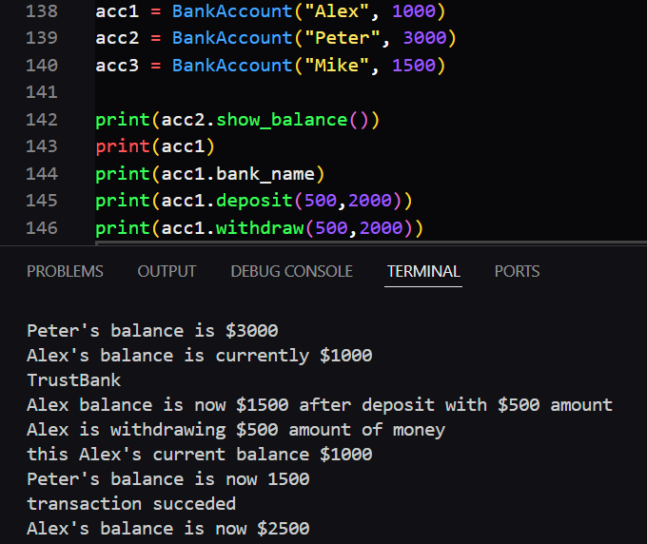

The implementation is lightweight, requiring no external libraries, and runs on any Python 3 environment, making it accessible for portfolio demonstration.

**Usage Instructions**

To use the Bank Account Management System, follow these steps:

1. **Prerequisites**: Ensure Python 3.6+ is installed on your system.
2. **Setup**:
   * Save the code in a file (e.g., bank_account.py).
   * No external dependencies are required.
3. **Running the Program**:
   * Open a terminal or IDE and navigate to the file’s directory.
   * Run the script using python bank_account.py.
   * The sample code creates three accounts (acc1, acc2, acc3) and demonstrates balance checks, deposits, withdrawals, and transfers.
4. **Customizing**:
   * Modify account details (e.g., name, balance) or transaction IDs in the script.
   * Test invalid scenarios, such as incorrect transaction IDs or insufficient funds, to observe error handling.
5. **Example Output**:



The system is designed for educational purposes, showcasing OOP concepts, but could be extended for real-world applications with additional security features.

**Challenges and Solutions**

During development, several challenges arose, reflecting common OOP learning hurdles:

* **Challenge**: Ensuring secure transaction verification without exposing sensitive data.
  + **Solution**: Implemented private attributes (__transaction_id) and methods (__verify_transaction) to enforce encapsulation, simulating banking security protocols.
* **Challenge**: Handling invalid inputs, such as insufficient funds or incorrect transaction IDs.
  + **Solution**: Added conditional checks in deposit, withdraw, and transfer methods, returning descriptive error messages (e.g., "insufficient funds").
* **Challenge**: Balancing simplicity with functionality for portfolio purposes.
  + **Solution**: Focused on core OOP concepts (e.g., encapsulation, instance methods) while keeping the code concise, avoiding unnecessary complexity like inheritance.

These solutions demonstrate problem-solving skills and attention to secure coding practices, valuable for cybersecurity and software development roles.

**Conclusion and Future Enhancements**

The Bank Account Management System successfully demonstrates fundamental Python OOP concepts, including classes, encapsulation, and instance methods, through a practical banking simulation. Its secure design, with private attributes and transaction verification, reflects real-world requirements and aligns with cybersecurity principles like data protection. For portfolio purposes, the project showcases technical proficiency, code organization, and problem-solving, making it an asset for career advancement in software development or cybersecurity.

Future enhancements could include:

* **Inheritance**: Create specialized account types (e.g., SavingsAccount, CheckingAccount) with unique features.
* **Polymorphism**: Implement method overriding for customized transaction behaviors.
* **Class/Static Methods**: Add utility functions, like calculating total bank funds.
* **Integration with Cybersecurity**: Incorporate logging or anomaly detection to monitor suspicious transactions, leveraging your Wazuh experience.
* **Database Integration**: Store account data persistently using SQLite, enhancing scalability.

By building on this foundation, the project can evolve into a more complex system, further demonstrating advanced skills.

**References**

1. Python Software Foundation. (2023). Python 3 Documentation: Classes. <https://docs.python.org/3/tutorial/classes.html>
2. Real Python. (2023). Object-Oriented Programming (OOP) in Python 3. <https://realpython.com/python3-object-oriented-programming/>
3. GeeksforGeeks. (2023). Python OOPs Concepts. <https://www.geeksforgeeks.org/python-oops-concepts/>